BASIC OPERATIONS OF POWERBI

STEP1: open powerbi and then retrieve data by using get data button on the tool bar

STEP 2: after clicking get data option select the text/csv from given data source to retrieve csv from local storage

STEP4:After opening csv file click on the transform data to clean data by removing data errors ,duplicates or we can delete unnecessary rows and columns to transform data set.

STEP 5:we can remove the blank by choosing the remove blank row.

STEP 6: we can delete the rowed section completely

STEP7:once the data transformation task is done then click on close and apply.

STEP 8:after loading the data go to the report view and visualize the dataset into desired format.

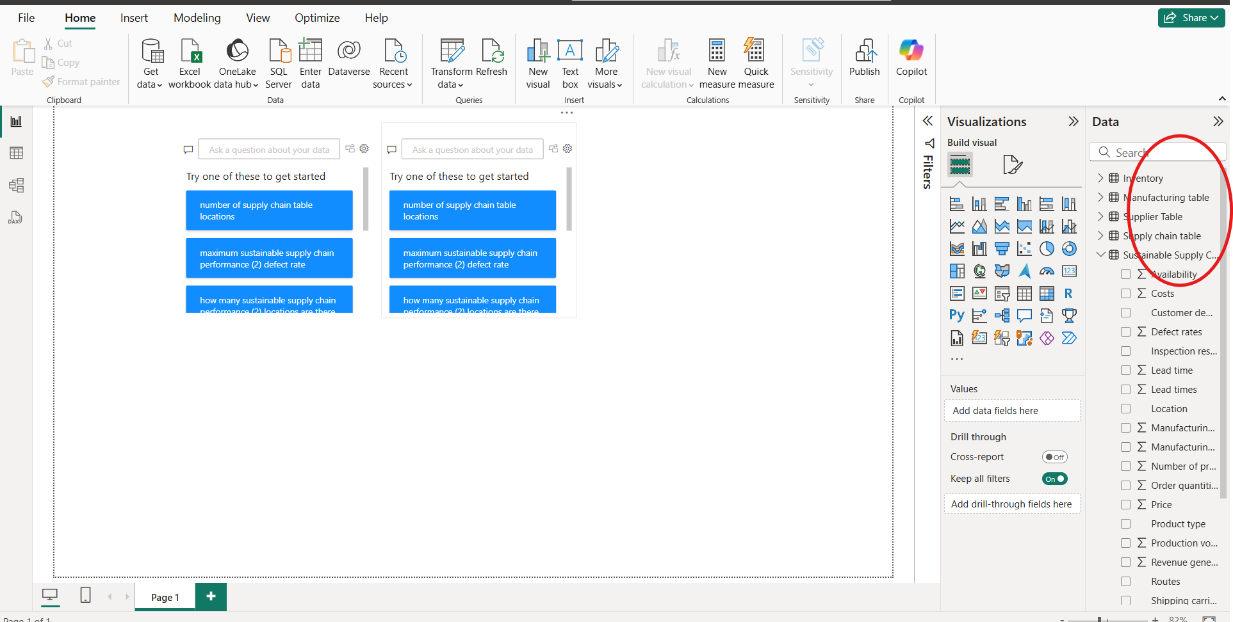

HENCE YOUR REQUIRED TASK IS COMPLETED.